- Create a new database called student_management
use student_management
- Create a collection called students in the student_management database
db.createCollection("students")
- Insert at least five student records into the students collection. Each record should have the following fields:
db.students.insertMany([
{student_id:101,name:"Akshay kumar",age:23,department:"Computer Science",courses:["HTML","DATABASE SYSTEM"],grade:"A"},
{student_id:102,name:"Salman khan",age:24,departement:"Information Technology",courses:["Btech","BCOM"],grade:"E"},
{student_id:103,name:"Shahid kapoor",age:20,department:"Hotel Manager",courses:["Bcom","BSC"],grade:"A"},
{student_id:104,name:"John Abraham",age:19,department:"Computer Science",courses:["DATABASE SYSTEM","BSC"],grade:"A"},
{student_id:105,name:"Amir khan",age:24,department:"Computer Science",courses:["PTHON","HTML"],grade:"D"}
])

#1 Retrieve all students who are in the "Computer Science" department.
db.students.find({department:"Computer Science"})

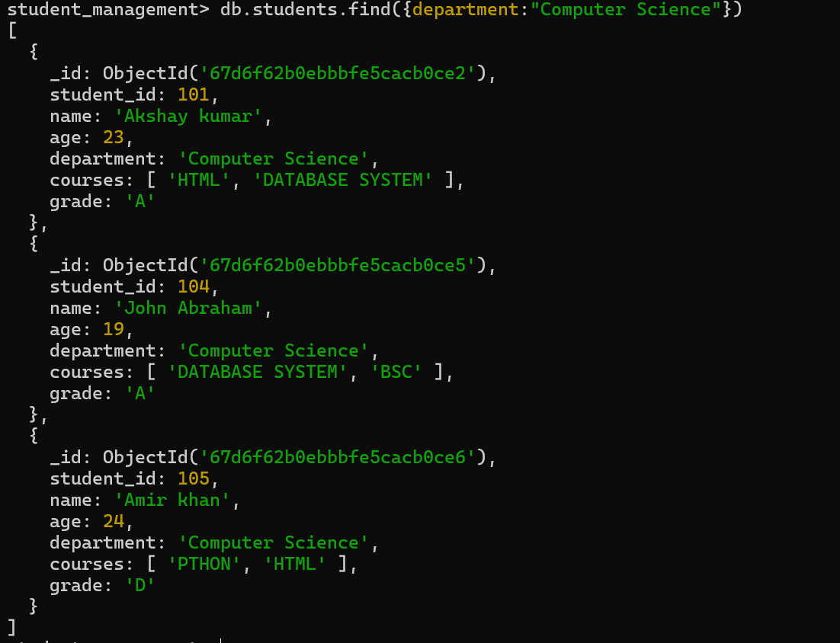

#2 Retrieve students who have an age greater than 21.
db.students.find({age:{$gt:21}})
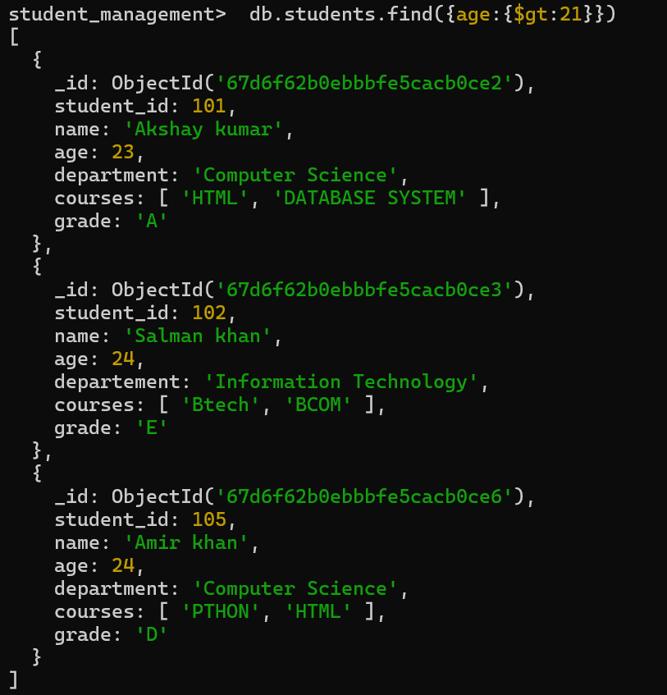

#3 Retrieve students who are taking the "Database Systems" course.
db.students.find({courses:"DATABASE SYSTEM"})

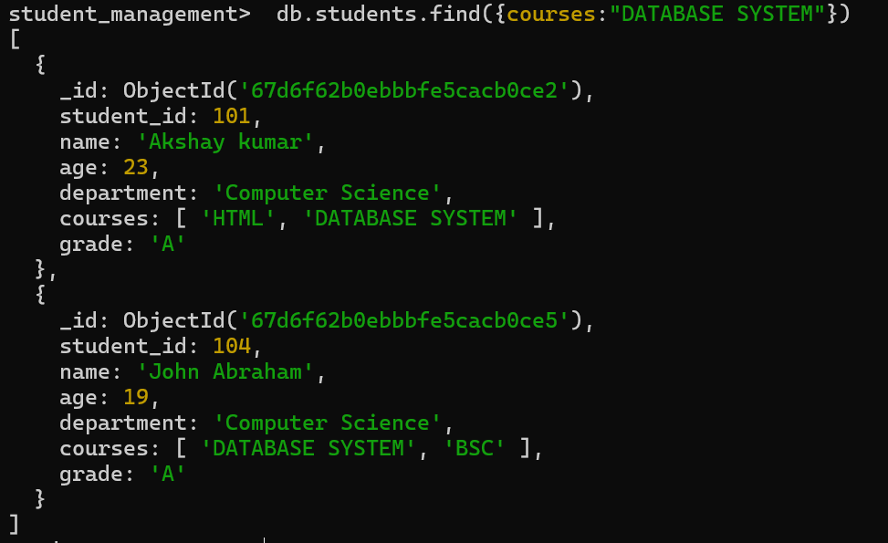

#4 Retrieve students with a grade of "A".
db.students.find({grade:"A"})
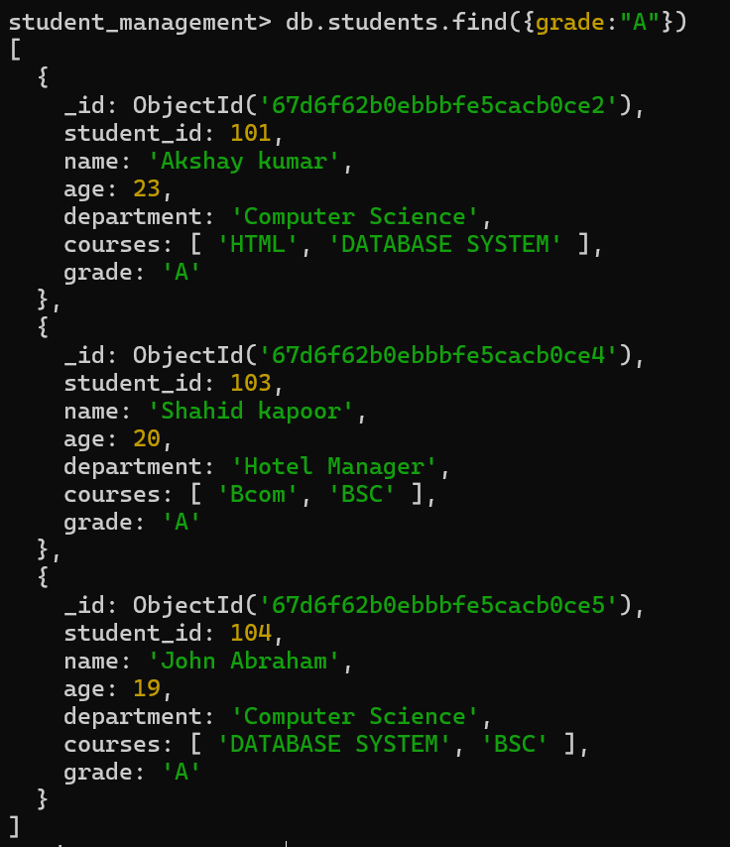

#5 Update the age of a student with student_id 101 to 21.
db.students.updateOne({student_id:101},{$set:{age:21}})
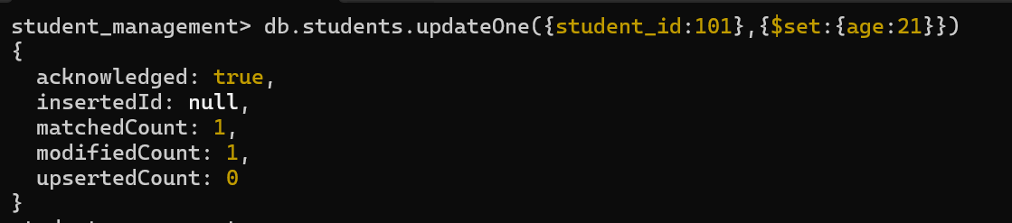
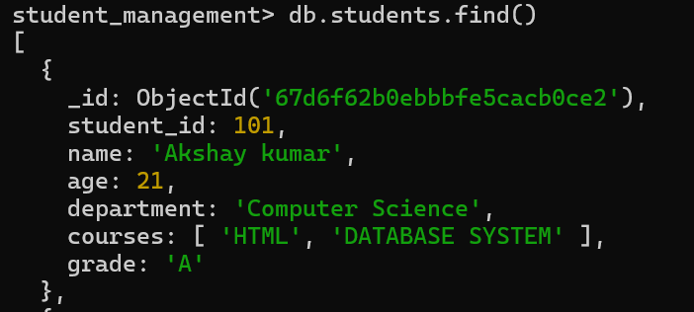

#6 Add a new course, "Machine Learning", to the courses array for students in the "Computer Science" department.
db.students.updateMany({department:"Computer Science"},{$addToSet:{courses:"Machine Learning"}})
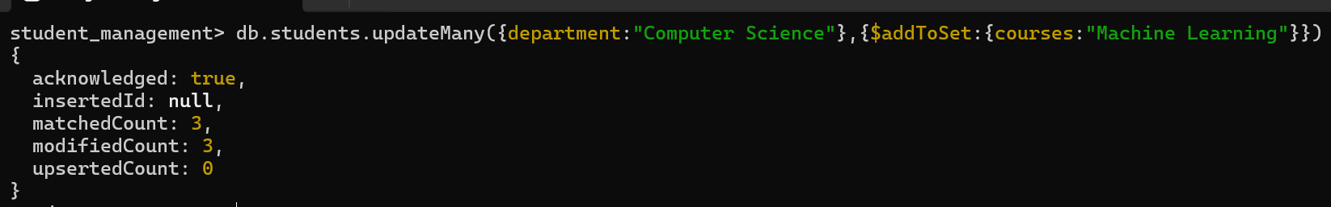
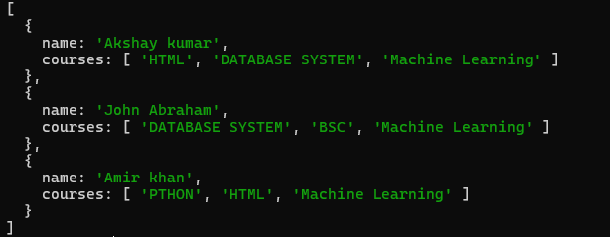

#7 Delete a student record with student_id 105.
db.student.deleteOne({student_id:105})
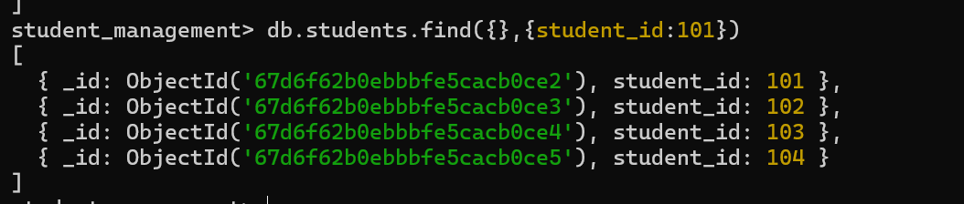

#8 Delete all students who have a grade lower than "C".
db.students.deleteMany({grade:{$lt:"C"}})
